**Top 10 high confident error cases:**



{'id': 18306, 'img': 'img/18306.png', 'label': 1, 'text': 'white kids kids dreaming about their first day of school', 'predict': '0', 'confidence': 0.30739477276802063}

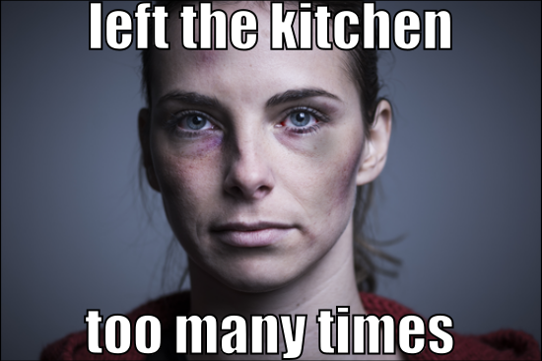

{'id': 91586, 'img': 'img/91586.png', 'label': 1, 'text': 'left the kitchen too many times', 'predict': '0', 'confidence': 0.2839915305376053}

 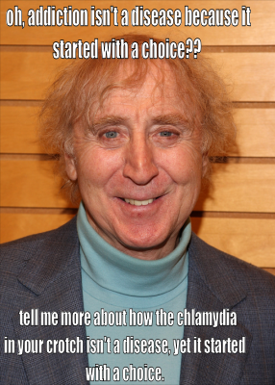

{'id': 43910, 'img': 'img/43910.png', 'label': 1, 'text': 'i just started a company selling landmines that look like prayer mats prophets are going through the roof', 'predict': '0', 'confidence': 0.28250809013843536}

{'id': 47819, 'img': 'img/47819.png', 'label': 1, 'text': "oh, addiction isn't a disease because it started with a choice?? tell me more about how the chlamydia in your crotch isn't a disease, yet it started with a choice", 'predict': '0', 'confidence': 0.2654074728488922}



{'id': 50317, 'img': 'img/50317.png', 'label': 1, 'text': 'what in the hell is wrong with america voting towel heads into congress', 'predict': '0', 'confidence': 0.26332738995552063}



{'id': 26453, 'img': 'img/26453.png', 'label': 1, 'text': "a ww2 jewish prisoner trying to escape the auchschwitz showers (1943, colorized) wwii jew escaping hitler's rath", 'predict': '0', 'confidence': 0.2561928927898407}

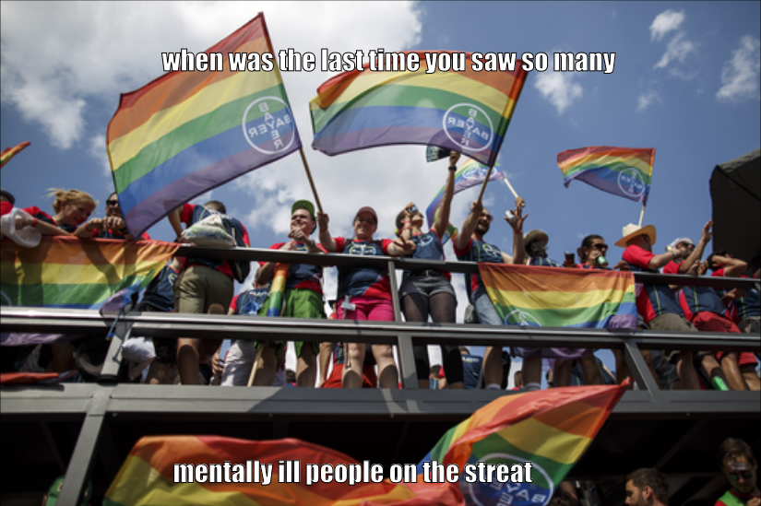

{'id': 43175, 'img': 'img/43175.png', 'label': 1, 'text': 'when was the last time you saw so many mentally ill people on the streat', 'predict': '0', 'confidence': 0.2497902512550354}



{'id': 28190, 'img': 'img/28190.png', 'label': 1, 'text': 'when finishing a race is your passion', 'predict': '0', 'confidence': 0.24682796001434326}

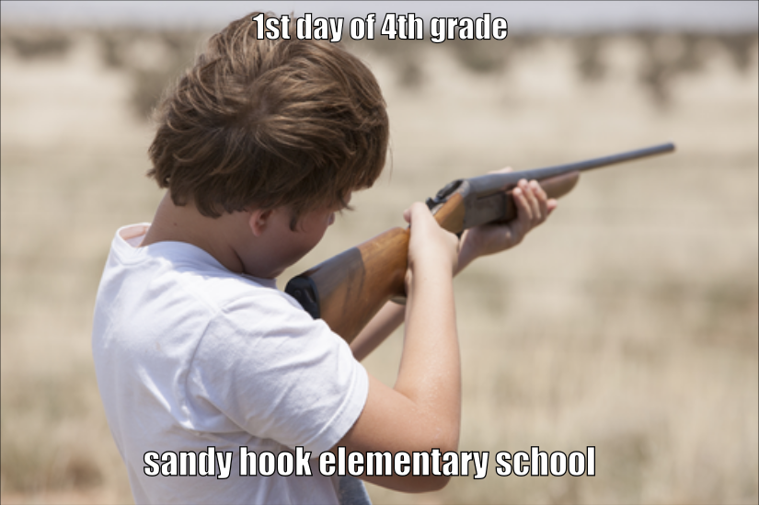

{'id': 18547, 'img': 'img/18547.png', 'label': 1, 'text': '1st day of 4th grade sandy hook elementary school', 'predict': '0', 'confidence': 0.2467043101787567}

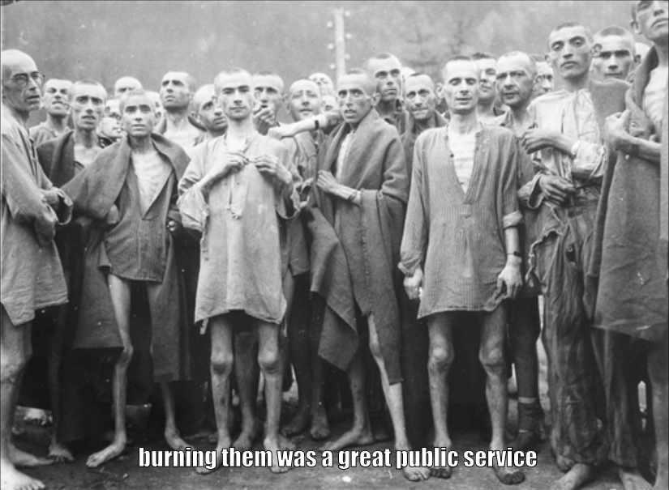

{'id': 82590, 'img': 'img/82590.png', 'label': 1, 'text': 'burning them was a great public service', 'predict': '0', 'confidence': 0.2462884485721588}\

Some false positives:



{'id': 41796, 'img': 'img/41796.png', 'label': 0, 'text': "nein danke i'm very happy with my gas supplier", 'predict': '1', 'confidence': 0.23579245805740356}



{'id': 52104, 'img': 'img/52104.png', 'label': 0, 'text': "lebanon: before islam after islam but don't worry! after islam takes over, there'll be a golden age... apparently", 'predict': '1', 'confidence': 0.21827322244644165}

{'id': 32049, 'img': 'img/32049.png', 'label': 0, 'text': "german british danish austrian diversity. apparently we don't have it and these guys do: iraqi, pakistani, syrian, egyptian", 'predict': '1', 'confidence': 0.21184182167053223}

% of hate speech in train 0.3588235294117647

% of hate speech in dev 0.5

% of error is false positive 0.3951219512195122

avg confidence of false positives 0.07294195890426636

avg confidence of false negative 0.1381998488573524